Nav Bar



Portfolio redirect error if not on homepage

<https://stackoverflow.com/questions/17687328/getting-a-link-to-go-to-a-specific-section-on-another-page>

<https://stackoverflow.com/questions/28503383/redirect-to-a-specific-part-of-the-page-with-a-link>

Carousel : Add Overlay as First Banner



Our Services : Delete text on the right corner

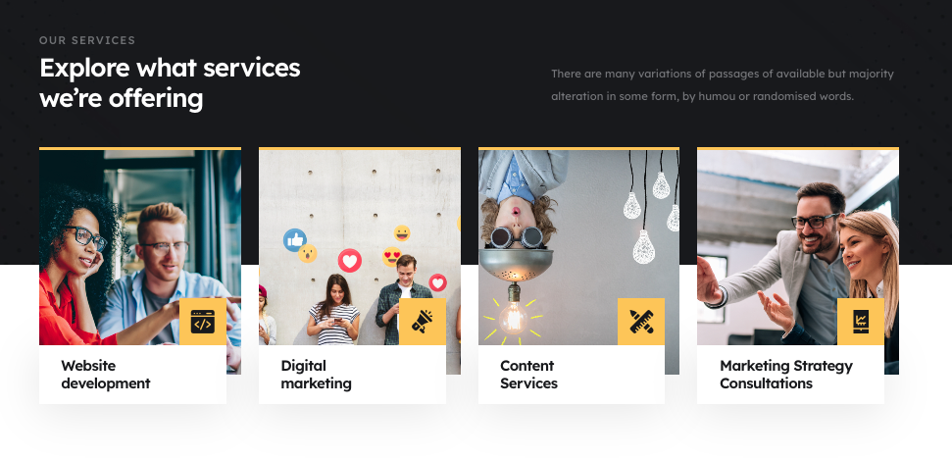

Testimonials : Replace scott’s image with a male pic



Company Benefits : Remove “.” in dedicated experts who breathe digital and change breathe to Breathe

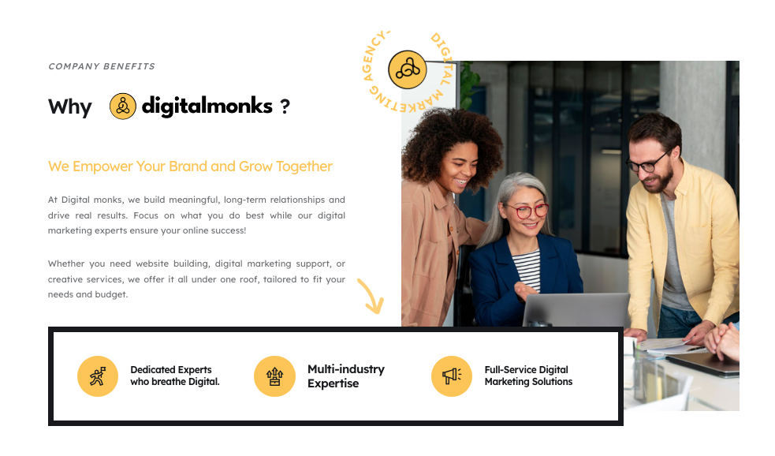

Get Inspired

Thumbnail for AI content is a bit skewed. Please crop and upload.

Can we enter a blank space for second blog to keep the boxes same height?

Also blog link should be open in a new tab

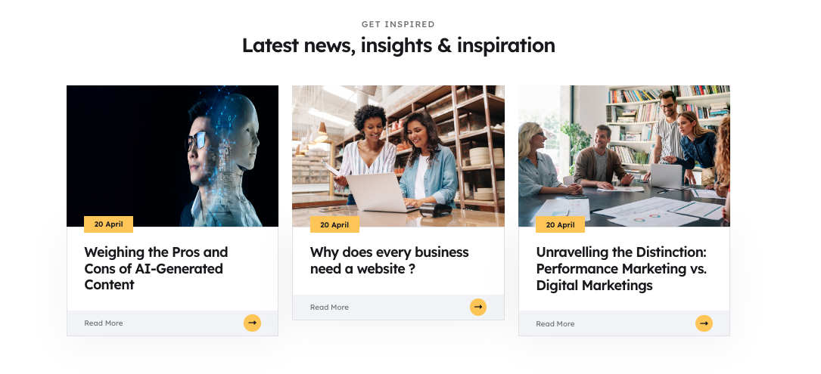

Can we hide this in the mobile view?



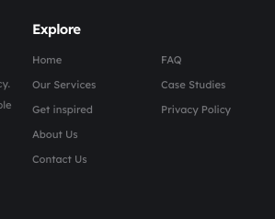

Links not working

Get Inspired

FAQ

**Services Page**

Please include the note in yellow text under all pricing boxes

Can we keep the height of boxes the same? (please enter blank spaces in each boxes to keep the height same

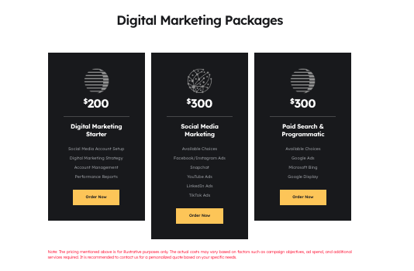

About Us:

Please change title to Digitalmonks

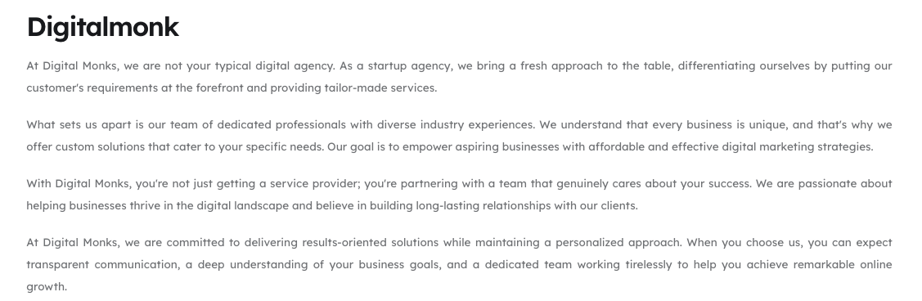

Please remove the share button on all photo

1. Photo 1:
   1. Name : Akhil Raj
   2. Digital Strategist
   3. 
2. Photo 2 : 
   1. Name : Gokul Prasad
   2. Digital Consultant
3. Photo 3:
   1. 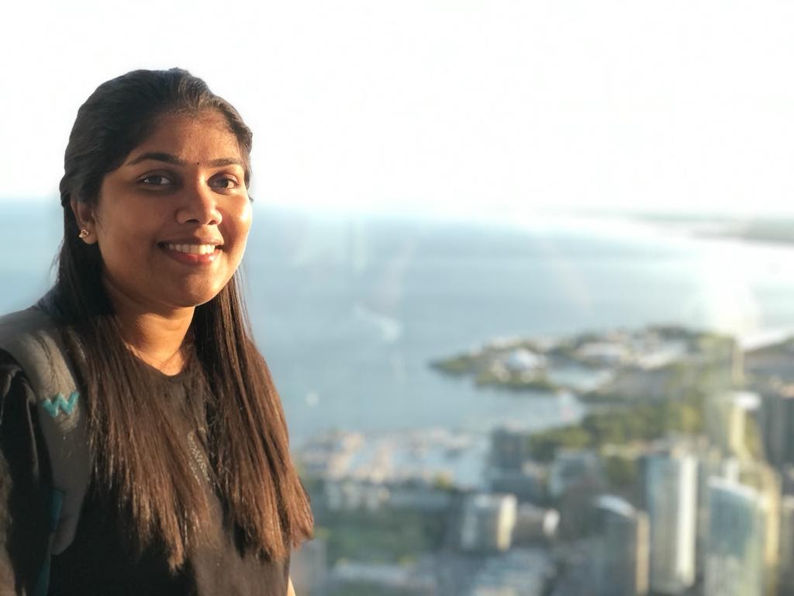
   2. Name : Nimisha
   3. Data Analyst

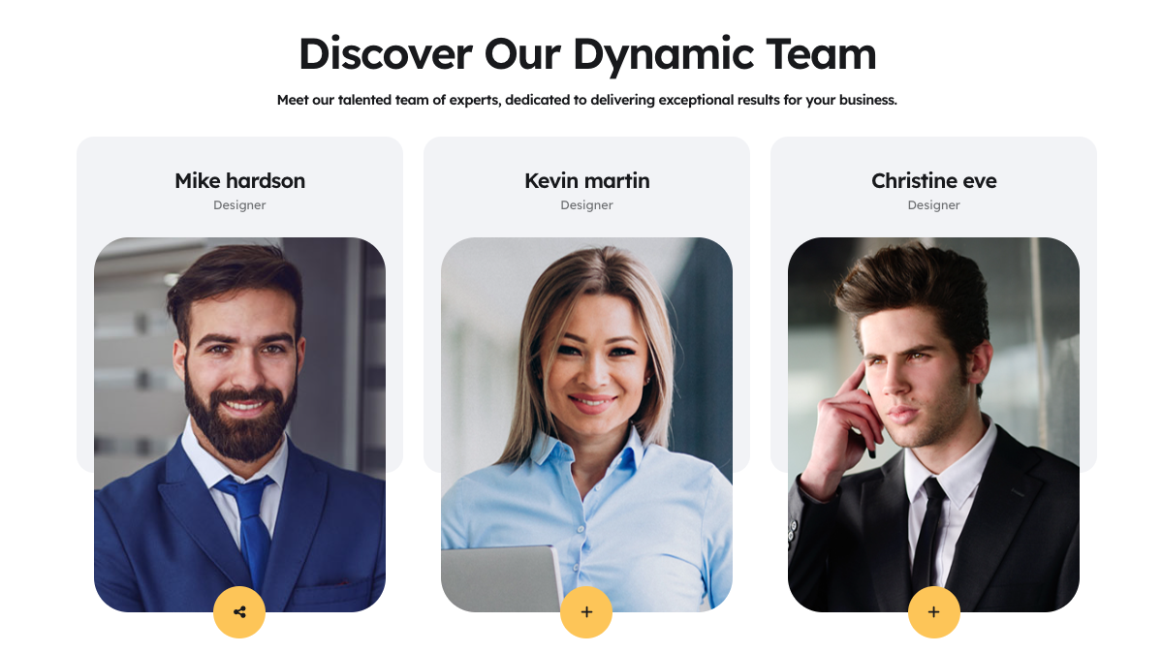

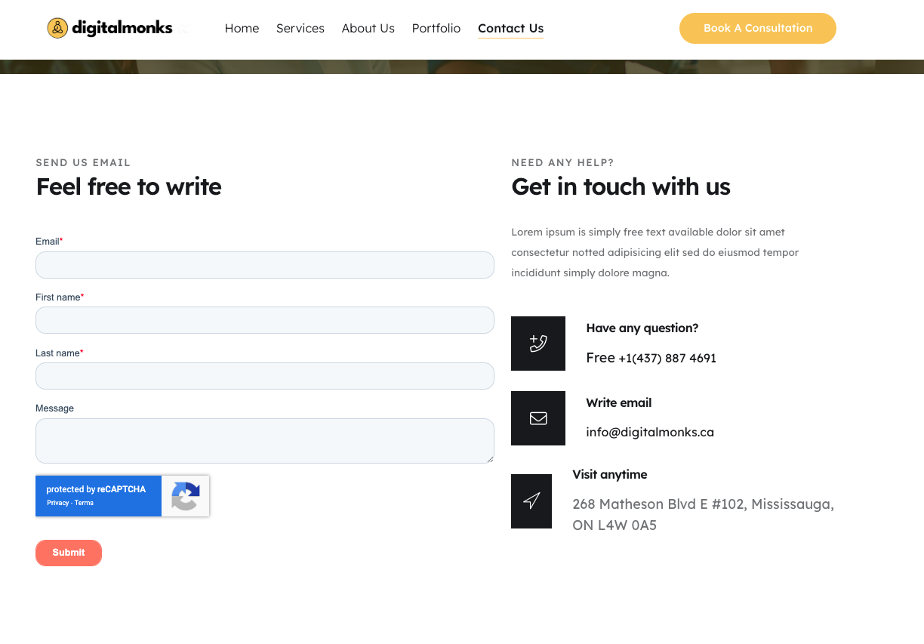

# **Please remove Visit anytime section.**

**Need a landing page design using the existing relevant sections used in digitalmonks.ca.**

Reference

1. <https://webdesigncruise.com/lp/web-cruise/?keyword=website%20development&matchtype=e&gclid=Cj0KCQjwzdOlBhCNARIsAPMwjbwqCKqtp-AMsKXpkWa6gbJjiMiCgPhOaLhMBzMbdhKS-thYXv_GgqMaAkGyEALw_wcB>
2. https://webdesignsmania.com/lp/web-development/?source=g&kw=website%20development&mt=p&ap=&gclid=Cj0KCQjwzdOlBhCNARIsAPMwjbyVZum-fAOCfm8SZygDkvqUy2W6zdhdF7AksO6hvYYFXz03i-56mngaAkykEALw_wcB